Decision Tree Accuracy: 0.99

Decision Tree Classification Report:

precision recall f1-score support

No 0.99 0.99 0.99 9864

Yes 0.96 0.96 0.96 1896

accuracy 0.99 11760

macro avg 0.97 0.97 0.97 11760

weighted avg 0.99 0.99 0.99 11760

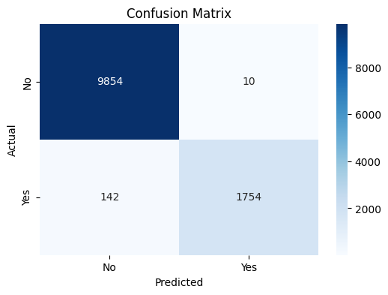 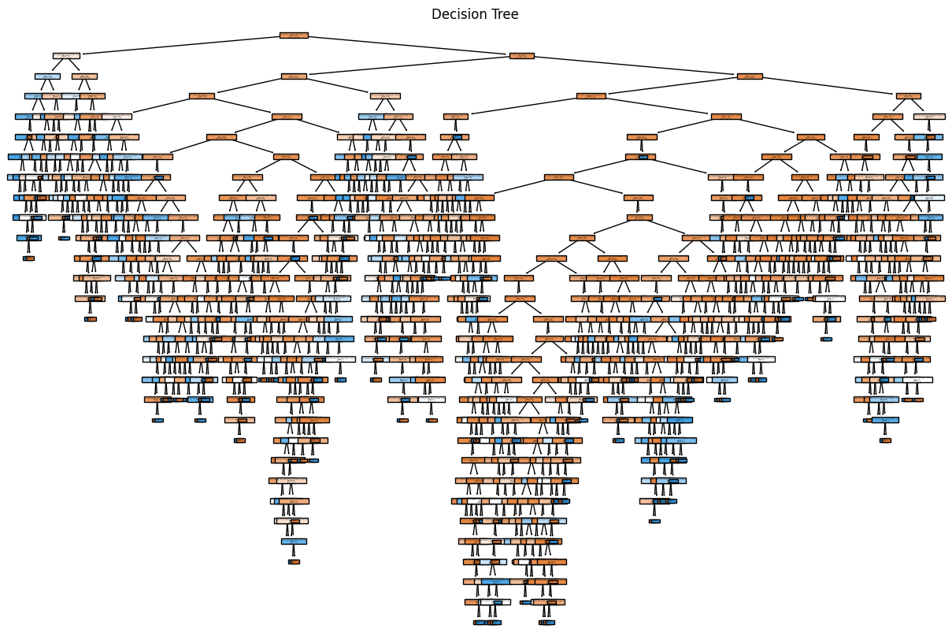

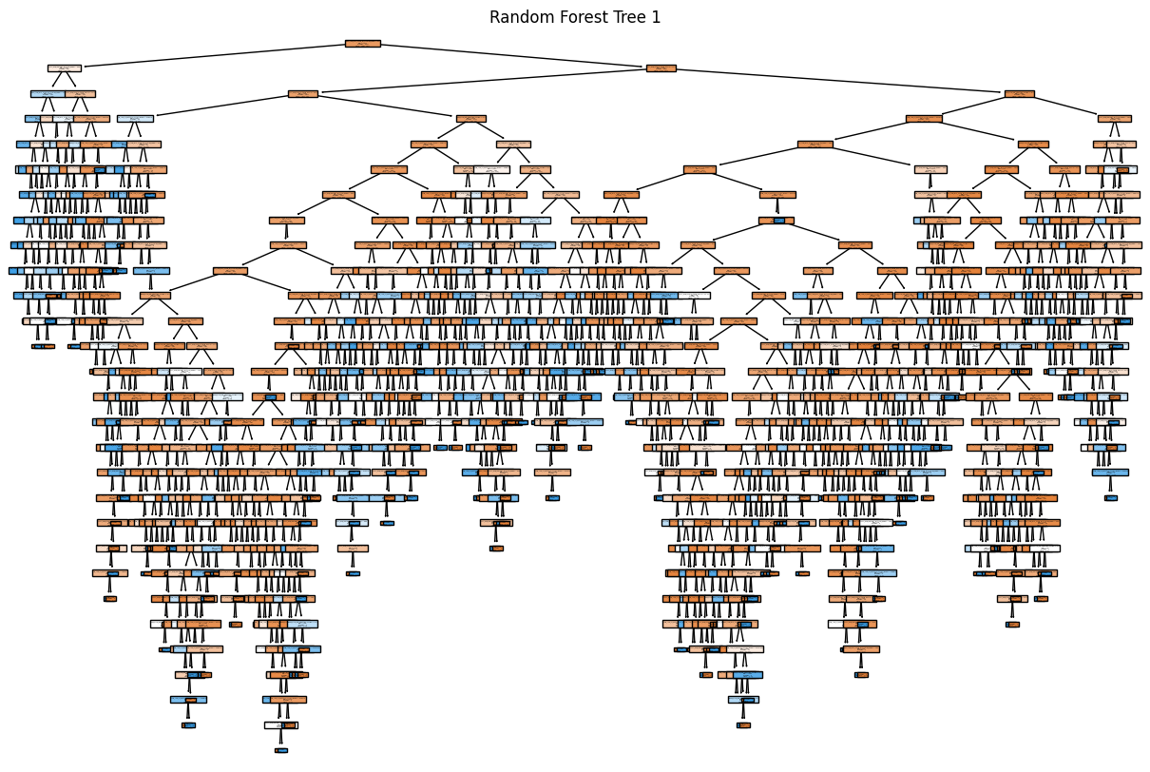

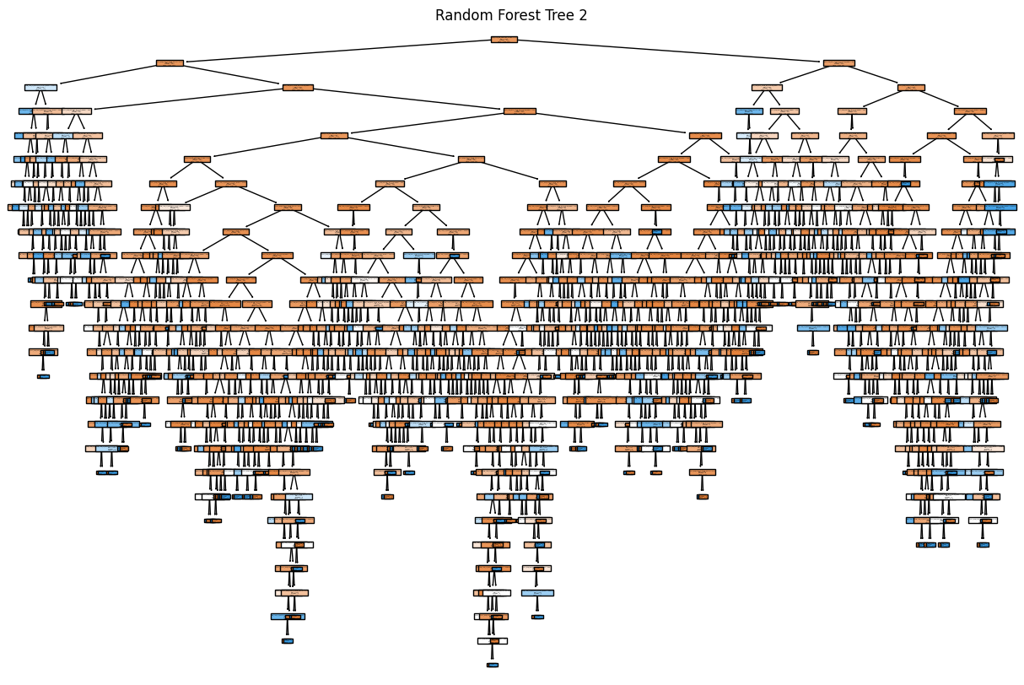

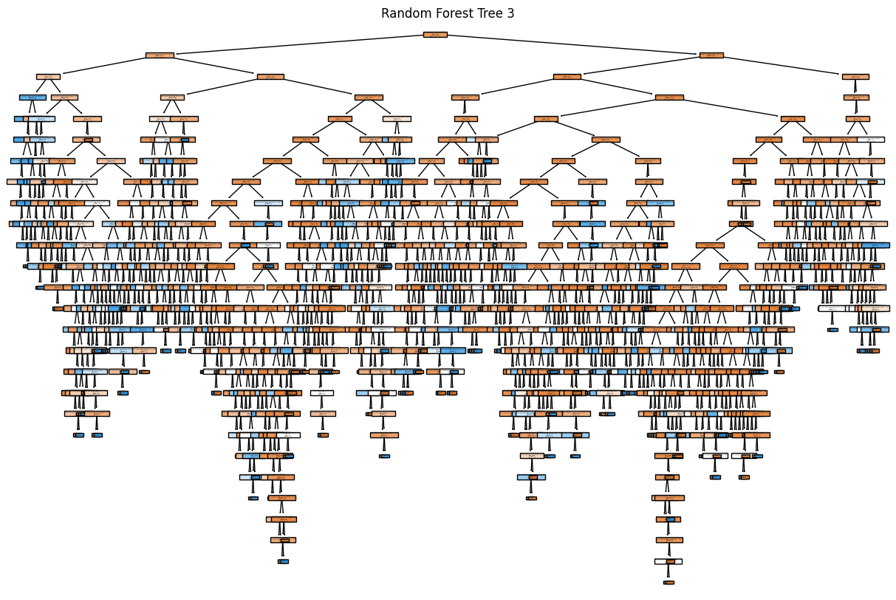

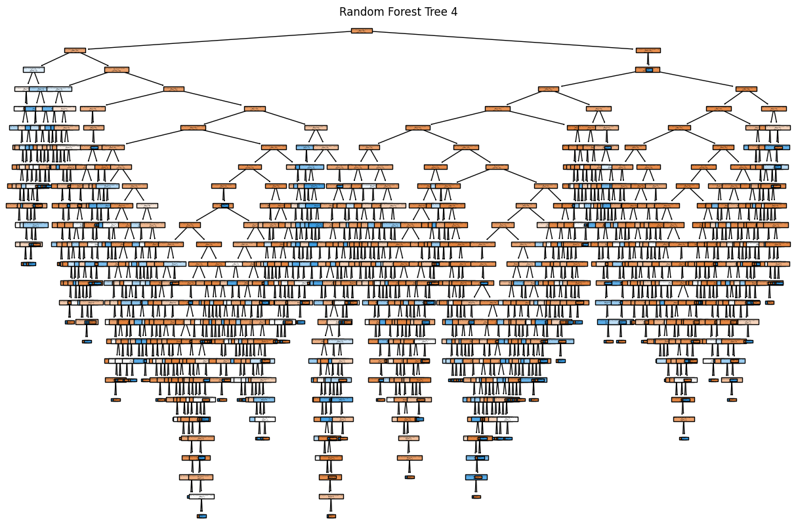

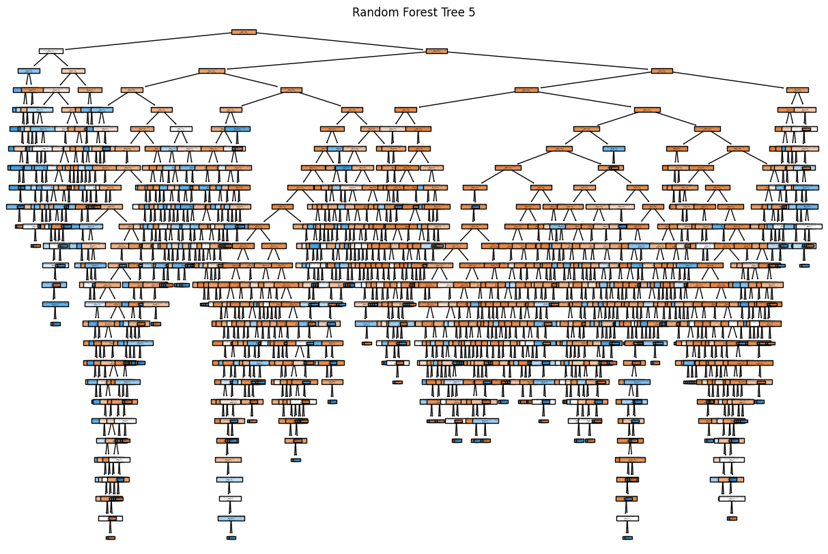

Random Forest Accuracy: 0.99

Random Forest Classification Report:

precision recall f1-score support

No 0.99 1.00 0.99 9864

Yes 0.99 0.93 0.96 1896

accuracy 0.99 11760

macro avg 0.99 0.96 0.98 11760

weighted avg 0.99 0.99 0.99 11760

